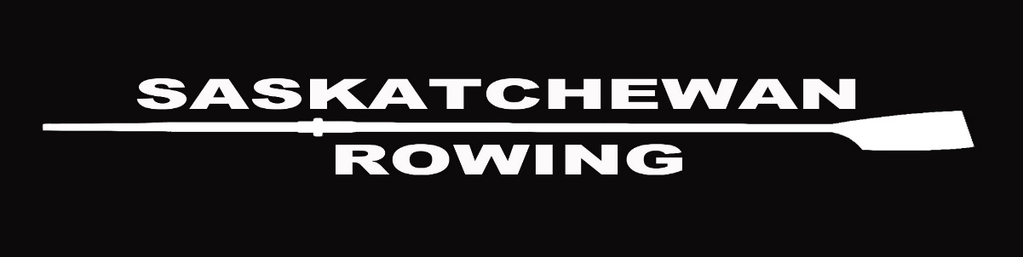

SASKATCHEWAN ROWING ASSOCIATION
ANNUAL GENERAL MEETING
Sunday June 14, 2020 – 10:00 am – via Zoom

Agenda

- Call to Order

- Roll Call

- Approval of Agenda

- Approval of Minutes from 2019 AGM
  - Errors and Omissions
  - Business arising

- Reports
  - Presidents Report
  - VP Admin
  - VP High Performance
  - VP Development
  - VP Programs
  - Coaches

  - Club Reports
    - RRC
    - SRC
    - LRC
    - PA Drifters

- New Business
  - Receive Financial Statements and Reports from Auditor
  - Appoint Auditor for 2020-2021 year
  - Election/appointment of Board Members
  - Safe Sport document from RCA for review only

- Adjournment

