Proposed Bylaw Amendments – Saskatchewan Rowing Association
In March of 2021, Saskatchewan Rowing Association Board of Directors passed a motion to move to a governance model moving away from the current management model. This involves making the necessary amendments to the Association’s bylaws and bringing those amendments before the Association’s membership for ratification at the Annual General Meeting, June 12, 2022.
There are 12 proposed bylaw amendments in total. These include: three new bylaws, 8 amendments to current wording in the bylaws, and 1 formatting amendment to update language use.
Listed below are the proposed changes as they relate to the existing by-laws as well as a rationale for each amendment following.
Bylaw Amendment Number One (1):
Any reference to the Corporation has been changed to Saskatchewan Rowing.
Rationale
AMENDED. The intention of this amendment is to allow improved readability and clarification throughout.
Bylaw Amendment Number Two (2):
Article 2: Objectives
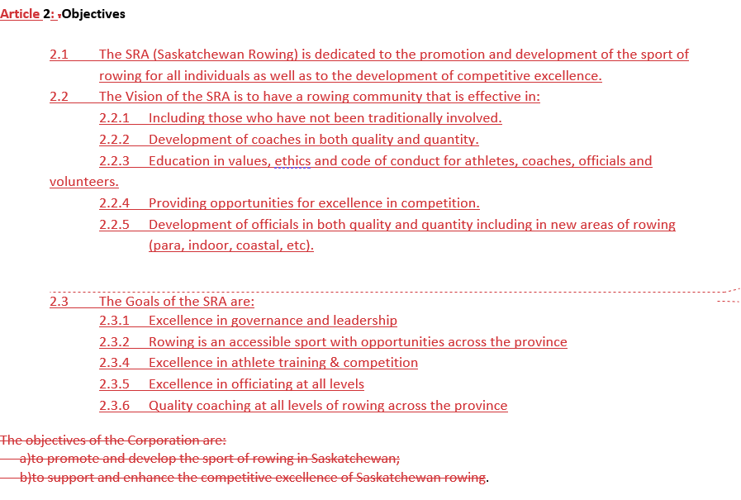
If amendment were approved by the membership the amended bylaw would read:

Article 2: Objectives
2.1 The SRA (Saskatchewan Rowing) is dedicated to the promotion and development of the sport of rowing for all individuals as well as to the development of competitive excellence.
2.2 The Vision of the SRA is to have a rowing community that is effective in:
2.2.1 Including those who have not been traditionally involved.
2.2.2 Development of coaches in both quality and quantity.
2.2.3 Education in values, ethics and code of conduct for athletes, coaches, officials and volunteers.
2.2.4 Providing opportunities for excellence in competition.
2.2.5 Development of officials in both quality and quantity including in new areas of rowing (para, indoor, coastal, etc).

2.3 The Goals of the SRA are:
2.3.1 Excellence in governance and leadership
2.3.2 Rowing is an accessible sport with opportunities across the province
2.3.4 Excellence in athlete training & competition
2.3.5 Excellence in officiating at all levels
2.3.6 Quality coaching at all levels of rowing across the province

Rationale
AMENDED. The intention of this amendment is to reaffirm the mission, vision and goals of the Saskatchewan Rowing Association and have them aligned with long range strategic plan.

Bylaw Amendment Number Three (3):
Article 3. Fiscal Year
If amendment were approved by the membership the amended bylaw would read:
3.1 The fiscal year of Saskatchewan Rowing shall be from April 1st to Mar. 31st in each year
Rationale
AMENDED. The intention of this amendment is to provide clarification of the fiscal year.
Bylaw Amendment Number Four (4):
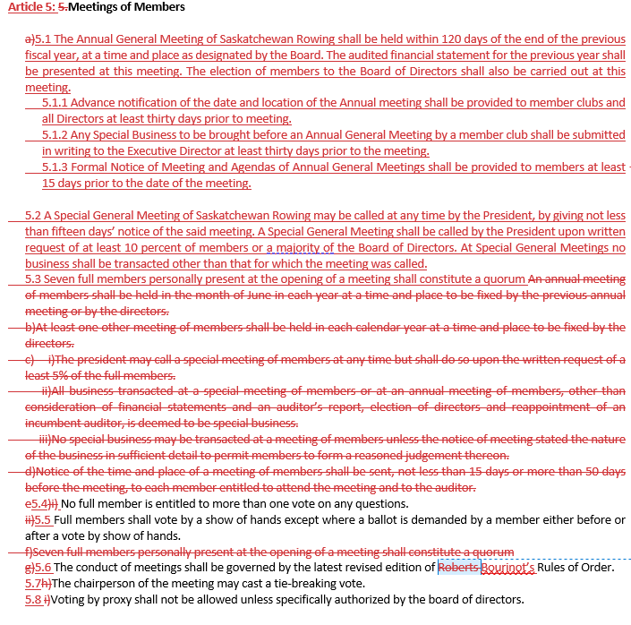
If amendment were approved by the membership the amended bylaw would read:
Article 5: Meetings of Members
5.1 The Annual General Meeting of Saskatchewan Rowing shall be held within 120 days of the end of the previous fiscal year, at a time and place as designated by the Board. The audited financial statement for the previous year shall be presented at this meeting. The election of members to the Board of Directors shall also be carried out at this meeting.
5.1.1 Advance notification of the date and location of the Annual meeting shall be provided to member clubs and all Directors at least thirty days prior to meeting.
5.1.2 Any Special Business to be brought before an Annual General Meeting by a member club shall be submitted in writing to the SRA Board at least thirty days prior to the meeting.
5.1.3 Formal Notice of Meeting and Agendas of Annual General Meetings shall be provided to members at least 15 days prior to the date of the meeting.
5.2 A Special General Meeting of Saskatchewan Rowing may be called at any time by the President, by giving not less than fifteen days’ notice of the said meeting. A Special General Meeting shall be called by the President upon written request of at least 10 percent of members or a majority of the Board of Directors. At Special General Meetings no business shall be transacted other than that for which the meeting was called.
5.3 Seven full members personally present at the opening of a meeting shall constitute a quorum
5.4 No full member is entitled to more than one vote on any questions.
5.5 Full members shall vote by a show of hands except where a ballot is demanded by a member either before or after a vote by show of hands.
5.6 The conduct of meetings shall be governed by the latest revised edition of Bourinot’s Rules of Order.
5.7 The chairperson of the meeting may cast a tie-breaking vote.
5.8 Voting by proxy shall not be allowed unless specifically authorized by the board of directors.
Rationale
AMENDED. The intention of this amendment is to better reflect notifications to membership regarding annual and special meetings. More clarification for staff and members regarding dates. Formatting has been changed to stay consistent with the document.

Bylaw Amendment Number Five (5):
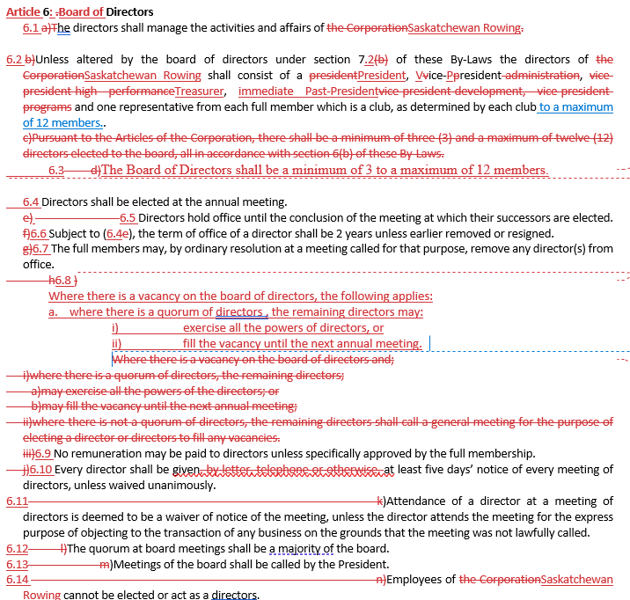
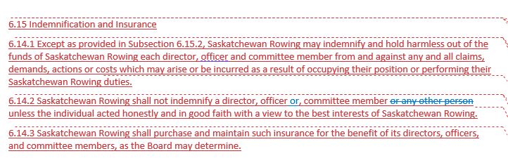

If amendment were approved by the membership the amended bylaw would read:
Article 6: Board of Directors
6.1 The directors shall manage the activities and affairs of Saskatchewan Rowing
6.2 Unless altered by the board of directors under section 7.2 of these By-Laws the directors of Saskatchewan Rowing shall consist of a President, Vice-President, Treasurer, immediate Past-President and one representative from each full member which is a club, as determined by each club to a maximum of 12 members.
6.3 The Board of Directors shall be a minimum of 3 to a maximum of 12 members.
6.4 Directors shall be elected at the annual meeting.
6.5 Directors hold office until the conclusion of the meeting at which their successors are elected.
6.6 Subject to (6.4), the term of office of a director shall be 2 years unless earlier removed or resigned.
6.7 The full members may, by ordinary resolution at a meeting called for that purpose, remove any director(s) from office.
6.8 Where there is a vacancy on the board of directors, the following applies:
where there is a quorum of directors, the remaining directors may:
- exercise all the powers of directors, or
ii) fill the vacancy until the next annual meeting; and
iii) where there is not a quorum of directors, the remaining directors shall call a general meeting for the purpose of electing a director or directors to fill any vacancies.
6.9 No remuneration may be paid to directors unless specifically approved by the full membership.
6.10 Every director shall be given at least five days’ notice of every meeting of directors, unless waived unanimously.
6.11 Attendance of a director at a meeting of directors is deemed to be a waiver of notice of the meeting, unless the director attends the meeting for the express purpose of objecting to the transaction of any business on the grounds that the meeting was not lawfully called.
6.12 The quorum at board meetings shall be a majority of the board.
6.13 Meetings of the board shall be called by the President.
6.14 Employees of Saskatchewan Rowing cannot be elected or act as a directors.

6.15 Indemnification and Insurance
6.15.1 Except as provided in Subsection 6.15.2, Saskatchewan Rowing may indemnify and hold harmless out of the funds of Saskatchewan Rowing each director, officer and committee member from and against any and all claims, demands, actions or costs which may arise or be incurred as a result of occupying their position or performing their Saskatchewan Rowing duties.
6.15.2 Saskatchewan Rowing shall not indemnify a director, officer or, committee member unless the individual acted honestly and in good faith with a view to the best interests of Saskatchewan Rowing.
6.15.3 Saskatchewan Rowing shall purchase and maintain such insurance for the benefit of its directors, officers, and committee members, as the Board may determine.
Rationale
AMENDED. The intention of this amendment is to support the move to a governance model with an Executive Director, the bylaws require updating to reflect a more up to date model of Officers and Directors. The significant change is moving away from President and VP’s to President, Vice President, Treasurer and that group making up the Officers which will be clarified in next Article. Formatting has been changed to remain consistent.
6.15 Indemnification and Insurance has been added to allow for and clarify the use of insurance, and liability of the directors.

Bylaw Amendment Number Six (6):
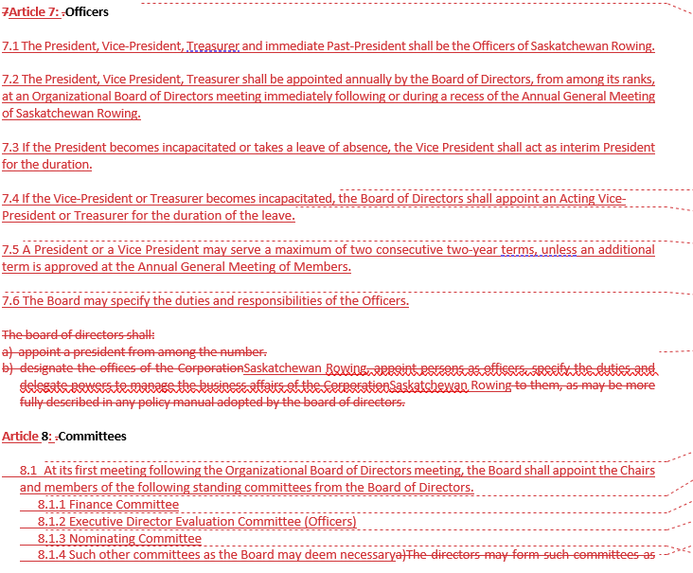
If amendment were approved by the membership the amended bylaw would read:
Article 7: Officers
7.1 The President, Vice-President, Treasurer and immediate Past-President shall be the Officers of Saskatchewan Rowing.
7.2 The President, Vice President, Treasurer shall be appointed annually by the Board of Directors, from among its ranks, at an Organizational Board of Directors meeting immediately following or during a recess of the Annual General Meeting of Saskatchewan Rowing.
7.3 If the President becomes incapacitated or takes a leave of absence, the Vice President shall act as interim President for the duration.
7.4 If the Vice-President or Treasurer becomes incapacitated, the Board of Directors shall appoint an Acting Vice-President or Treasurer for the duration of the leave.
7.5 A President or a Vice President may serve a maximum of two consecutive two-year terms, unless an additional term is approved at the Annual General Meeting of Members.
7.6 The Board may specify the duties and responsibilities of the Officers.
Rationale
AMENDED. The intention of this amendment is to support the move to a governance model with an update to officers. The duties of these Officers will be described in policies approved by the Board.

Bylaw Amendment Number Seven (7):
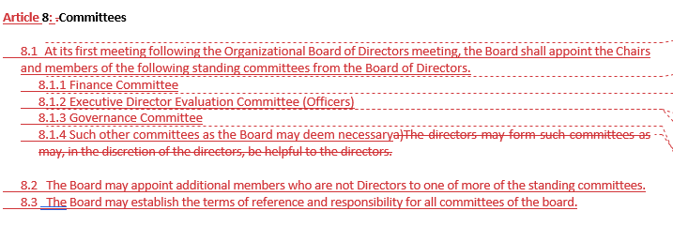
If amendment were approved by the membership the amended bylaw would read:
Article 8: Committees
8.1 At its first meeting following the Organizational Board of Directors meeting, the Board shall appoint the Chairs and members of the following standing committees from the Board of Directors.
8.1.1 Finance Committee
8.1.2 Staff (Executive Director) Evaluation Committee (Officers)
8.1.3 Governance Committee
8.1.4 Such other committees as the Board may deem necessary
8.2 The Board may appoint additional members who are not Directors to one of more of the standing committees.
8.3 The Board may establish the terms of reference and responsibility for all committees of the board.
Rationale
AMENDED. The intention of this amendment is to ensure the appropriate fiduciary oversight of the organization as it moves to a governance model. The functions of these standing committees will be described in policies approved at the Board level.

Bylaw Amendment Number Eight (8) is a new bylaw:
Article 9: Staff
9.1 Saskatchewan Rowing will employ staff such as an Executive Director who shall be responsible to the Board of Directors for the efficient management of Saskatchewan Rowing within the Bylaws, budget(s) and policies established by the Board of Directors.
Rationale
NEW. This addition of this bylaw ensures that the Board has the power to hire appropriate staff to execute the strategic direction of the organization as it moves to a governance model. The duties of this staff will be prescribed in their contracts and by Board policy.
Bylaw Amendment Number Nine (9):
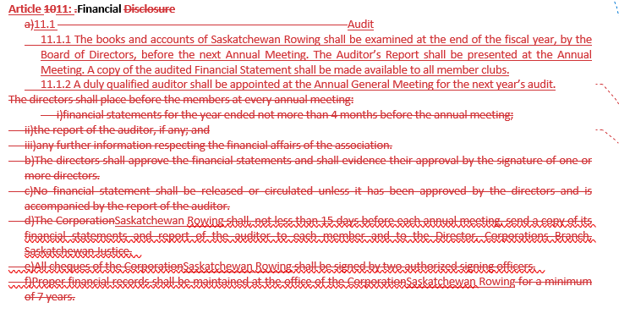
If amendment were approved by the membership the amended bylaw would read:
Article 11: Financial
11.1 Audit
11.1.1 The books and accounts of Saskatchewan Rowing shall be examined at the end of the fiscal year, by the Board of Directors, before the next Annual Meeting. The Auditor’s Report shall be presented at the Annual Meeting. A copy of the audited Financial Statement shall be made available to all member clubs.
11.1.2 A duly qualified auditor shall be appointed at the Annual General Meeting for the next year’s audit.
Rationale
AMENDED. The intention of this amendment is to simplify process and remove unnecessary language that is better included in Finance Policy. Update formatting and numbering.
Bylaw Amendment Number Ten (10):

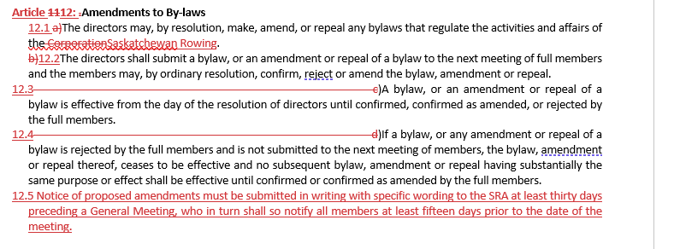
If amendment were approved by the membership the amended bylaw would read:
Article 12: Amendments to By-laws
12.1 The directors may, by resolution, make, amend, or repeal any bylaws that regulate the activities and affairs of Saskatchewan Rowing.
12.2 The directors shall submit a bylaw, or an amendment or repeal of a bylaw to the next meeting of full members and the members may, by ordinary resolution, confirm, reject or amend the bylaw, amendment or repeal.
12.3 A bylaw, or an amendment or repeal of a bylaw is effective from the day of the resolution of directors until confirmed, confirmed as amended, or rejected by the full members.
12.4 If a bylaw, or any amendment or repeal of a bylaw is rejected by the full members and is not submitted to the next meeting of members, the bylaw, amendment or repeal thereof, ceases to be effective and no subsequent bylaw, amendment or repeal having substantially the same purpose or effect shall be effective until confirmed or confirmed as amended by the full members.
12.5 Notice of proposed amendments must be submitted in writing with specific wording to SRA at least thirty days preceding a General Meeting, who in turn shall so notify all members at least fifteen days prior to the date of the meeting.

Rationale
AMENDED. The intention of this amendment is to ensure the Board and staff have enough time to prepare documents for membership review prior to an AGM.

Bylaw Amendment Number Eleven (11) is a new bylaw:
Article 13: Conflict of Interest
13.1 Directors or employees of Saskatchewan Rowing shall not accept expenses, honorariums or other benefits exceeding $500 in value from rowing related sources outside Saskatchewan Rowing or Rowing Canada without prior full disclosure and authorization.
13.2 Any Director or employee who has a financial interest in a company bidding on a contract with the Association shall make such interest known to the Board and shall not participate in the decision to award the said contract. This section shall also apply in cases where a close relative of the Director or employee has a financial interest.
13.3 Directors or employees of Saskatchewan Rowing shall not present themselves as representing Saskatchewan Rowing in any personal business or other personal activities.

Rationale
NEW. Article 13 adds a conflict of interest guideline, in acknowledgement of the gravity of the implicit trust and duty of care inherent in the board members commitment to the position.

Bylaw Amendment Number Twelve (12):
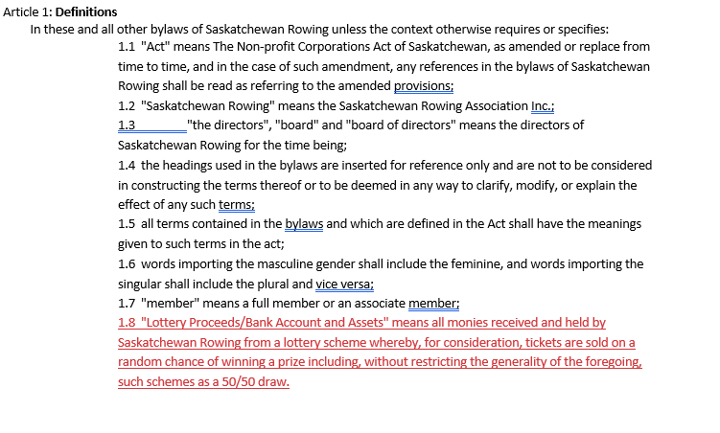
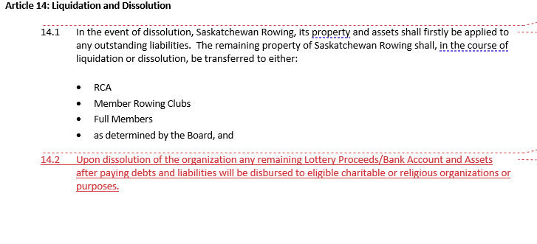
Rationale
AMENDED. The intention of this amendment is to ensure bylaws reflect requirements of Saskatchewan Liquor and Gaming for dealing with lottery proceeds. The definitions are amended to include Lottery Proceeds and Bank Accounts as well as article 14.

